NOTE: do a ctrl + f for “(ref)”, to see where refs need to be filled in
Introduction:
The host-associated microbiome is an ecosystem defined by its complexity and mystery. For any given organism there can be thousands of bacterial species inhabiting every square inch of external and internal surface. Over time, common interactions, whether mutualistic or competitive, can drive selection for specific traits in areas of microbiome, which may be different on different surfaces of a single organism (ref). For some species, this leads to heavy adaptation to that niche, becoming a specialist. However, many more species of bacteria are generalists, able to survive in the environment, and colonise the host microbiome regularly (ref). These species are defined by their genomic plasticity and variability, as well as many having a large repertoire of conserved genes (ref).
Vertebrate taxa are known for being some of the most diverse on Earth, inhabiting all of the ecosystems on the planet, and encompassing a vast array of lifestyles (ref). In spite of this variation, there are many generalist bacterial species found ubiquitously across vertebrate host-associated microbiomes. It stands to reason that these generalist bacteria are subject to the same selection pressures driving the adaptation of specialists. Owing to their genetic variability, they should be able to comparatively show the differing signals of selection at a wide-scale, across multiple Classes of vertebrate host (ref?). Previous work in this area inclused (ref) [that one paper about vertebrate class-level microbiomes]
One such of these generalist bacterial taxa is the Genus Pseudomonas, a clade with a long history of study (ref). It can be found ubiquitously across a wide variety of environments and ecosystems, spanning both terrestrial and aquatic environments (Spiers et al., 2000). As such, it has the potential to colonise vertebrates inhabiting said array of ecosystems. At the time the genome of P. aeruginosa was first sequenced, it was the largest bacterial genome ever seen, presenting the wide variety of genes held within (Stover et al., 2000). As such, previous study has focused on the functional divergence of Pseudomonas between different environments, finding variation in the enrichment of genes concerning metabolism. Namely, which molecules the bacteria chose to metabolize (Saati-Santamaría et al., 2022).
In this instance, enrichment, specifically Over Enrichment Analysis (ORA), refers to identifying genes that are significantly more prevalent in one group or another, suggesting correlation. This can be done in may ways... (ref). It is useful as (ref). However, there are, at present, limitations to this type of analysis. Namely, enrichment software will remove genes from the background list if they are not yet of known function, and some software under-estimating the number of tests conducted for significance, leading to false positives (Ziemann et al., 2024).
(García-Campos et al. 2015) – paragraph on pathway analysis specifically
This analysis requires large amounts of data. One such place to get it is online repositories. These are databases of genomic sequences, and their associated metadata. These databases store vast quantities of data that researchers have previously generated. This means that the data can be copied from storage by future researchers and used for the generation of novel analysis. Such as, by performing pathway analysis on multiple taxa that are not generally sequenced together to look for over representation. They represent sources of data with a high potential, especially considering they do not associate any cost, compared to de novo sequencing. This is especially important for microbial genomics, as many sequences are Metagenomic Assembled Genomes (MAGs). Creating these requires a complicated process of library preparation, deep shotgun sequencing and computational algorithms. Due to this complexity, different methods find different amounts of success, in part making metagenome assembly as expensive as it is (Chivian et al., 2022). This makes public genomic repositories very ideal, in theory, to microbial analysis. Data from these sites can supplement analyses, helping strengthen the statistics involved, and keep costs down to allow a wider range of analysis. However, few studies rely purely on data from these public sites (ref). [Is that true? Can I find a paper?] As an important data source, it is vital to characterise its abilities, and limitations, for novel analysis in its own right, without being supported by new, ideal, lab-made data. This is especially important for microbial analysis, where culturing new strains in the lab may be expensive, or even impossible (ref).

Methods:
Metadata collection and filtering
Data was collected via downloading the genomic sequences of all individuals listed under the genus Pseudomonas in their associated metadata from the NCBI genomic database (ref)(maybe link to the front-end, and an expl of how I downloaded?). This was done on the 8th of December 2025, yielding ~60,000 individuals (check). Steps were then taken to filter these to those with wild animal hosts which showed high quality metrics. These were then grouped, so analysis could be performed between group-level libraries of pathway enrichment. Wild hosts were chosen as humans and domestic animals have close contact with antibiotics, which have proven to disrupt natural microbiomes (ref). However, in many cases, it is impossible to know for certain if a host was a non-domesticated species, but of study in a lab, so with potential for a disrupted microbiome, due to the lack of information in the metadata. The genAI tool Claude.ai (ref) was used to group the hosts of samples into “Domestic”, “Wild”, or “Both”, wherein it was likely, but inconclusive that the sample came from a non-wild environment. In the interest of transparency with AI tools, exact decisions are shown in supplementary table S1.
Grouping samples at the Class level was determined to be the ideal level, as the level of Order would produce too many small groups, and the level Phylum would be too broad for meaningful analysis. As Class Insecta was distinct as an invertebrate taxa, it was cut from analysis, leaving 4 Vertebrate taxa; Amphibia, Aves, Mammalia and Osteichthyes. Due to the lack of consistency in the metadata, with values in the host field occasionally being the latin scientific name, or an English name, or potential nicknames and misspellings, Claude.ai was again used in grouping, values in supplementary table S2. Finally, quality metrics were taken from the metadata as the CheckM scores (ref). Specifically, a completeness of 80% or higher and contamination of 15% or lower. These values were chosen to allow a statistically significant number (n=30) of Amphibian samples, so as the group could be included in analysis. This resulted in a remaining 337 samples for the study, the distribution of these between the host groups is seen in Table 1. Similarly, a table linking the bacterial samples to their hosts groups was created, specifically, breaking down the host groups by species of Pseudomonas, visualised in Table 2.
A phylogenetic tree was constructed to identify the evolutionary relationships between the samples of the study, this was created using GTDB-Tk version 2.3.2 and is visualised in Figure 1. This was created using the de_novo_wf workflow to create a novel tree from the samples of this dataset. This was then processed and developed in R studio, firstly pruning the reference samples GTDB-Tk placed in the tree to structure it, then removing 1 branch that was too evolutionarily distinct, and subtracted from the clarity of the figure. Beyond this, metadata about the samples were brought in to identify bias in the data, this includes the taxonomic assignments given to each sample on the NCBI database, the host group and the country of origin. The latter was taken at a continental-country scale, as this allowed for an ideal number of grouping variables. Namely, the countries where the most samples originated from remained countries, and those with fewer samples were grouped into continent or sub-continent scale. This was done with Claude.ai, and visualised in Supplementary Table S3. [more?]
Table 4 – count by country?

Data processing pipeline
Annotation
In order to perform pathway analysis, the genomic sequences first needed to be annotated. EggNOG-mapper version 2.1.12 (ref) was used to do this. The pipeline for this tool was split into its 3 constituent functions, and each was ran separately, as this increased the speed of the annotation. Similarly, instead of running this process over each genome in turn, the label for the genome was modified to include the ID for the sample, and these were all combined into 1 input file, similarly increasing the processing speed. Firstly, the genomic sequences needed to be translated into protein sequences. This was done using Prodigal version 2.6.3 (ref). These protein sequences then needed to be annotated for the genes present. This was split between the sub-functions of EggNOG-mapper or “search” and “annotate”, producing an annotations.tsv file.
Enrichment
In this output, these genes were assigned to KEGG Orthologous Groups, or Orthologs (KOs). These are groupings of genes of shared function that KEGG (ref) have curated for purposes such as this study. Once genes have been assigned to KOs, these KOs are then placed in known pathways, being larger-scale biological functions that these KOs play a part in. Amount of KOs in each given pathway for each group can be compared statistically, to identify significant differences between groups. The tool used for this study was the “enrichKO” function of the R package MicrobiomeProfiler (ref). Input into this process were unique lists of KOs that appear in each group, as well as a unique list of all KOs that appeared in every group, taken as the background “universe”. This was chosen as it showed the total repertoire of potential adaptations to these groups, similar to work by Zhang et al., 2025. [This is still the bit I am stuck on, it makes sense to do it the way I did, but what would be different about doing it individual by individual, like Aaron?] Also, the first step of enrichKO is to make the list of KOs passed in unique, thus, doing this before analysis sped up processing time. Not all genes have known KOs, and similarly, not all KOs are of known pathways, thus, some information was lost along this pipeline as these repositories of information are thus far incomplete. The remaining KOs of these groups in every case made up a great majority of the background, as shown in Table 3. [getting into results here, need to rephrase in a more methods-y way].
Code is available in the GitHub repo associated with this study:
https://github.com/tobiasnunn/undergrad_dissertation

Data analysis
The enrichKO function assigns each pathway for each group a p value, to display that a pathway is significantly over-represented in a group. This value is then adjusted with the Benjamini-Hochberg Procedure (ref) to reduce the number of false positives by accounting for bias in the data [is that right, there were specific words that were used]. Thus, this value was taken to infer that a pathway significantly correlates with a host group. Thus, Figure 2 was created, displaying pathways which were found enriched in 1 group (p.adjusted < 0.05) and not for the other 3 (p.adjusted > 0.05). Figure 3 represents the pathways which could be found enriched in more than one group.

This data was surported by secondary analysis where each genome was ran in turn through enrichKO… [Think it would be good to do this to see what happens]
A third analysis was done taking the regular p value [I want to see what the BH does]
Combine Aarons analysis with using just the p value maybe, also, revisit the reworked figures, make damn sure I did those right.
Include Isolation Source?
I think a good supplemental figure would be a heatmap of the original enrichment analysis, but with the p value, not adjusted, like a “This is what the BH is doing”
Which modules of the pathways?

Ethics statement
This research was screened under Bangor University’s Research Ethics Framework and no issues were identified {is that true, or am I making that up?}

Results:
Descriptive tables
After the filtering steps, mentioned in Methods, the remaining subset of genomes numbered 337, split between 4 groups of unequal size. Specifically, Mammal-hosted and Fish-hosted Pseudomonas numbered much higher, at 140 and 113 each. Compared with the 54 and 30 for Bird-hosted and Amphibian-hosted Pseudomonas. It should be noted that Class Insecta-hosted Pseudomonas had roughly 60 genomes. However, it was excluded, due to being too different from the other 4 groups. It is possible this had an impact on analysis [this is a conclusion]
Table 1 - Count of Pseudomonas bacterial samples by host's taxonomy at level of Class
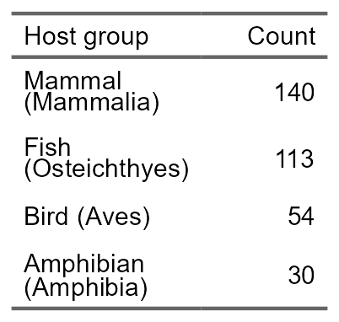

Table 2 displays the 10 largest species of Pseudomonas present in the study. It shows that the second largest group is “Pseudomonas sp.”, meaning of unknown species. [build up]
Table 2 is a subset of this data, as many samples are of strains where only 1 individual has been identified. The majority of these groups are visualised in Figure 1. [build up]
Table 2 - Count of Pseudomonas genomes, used in study, grouped by bacterial species. Subset, 10 largest groups by count.
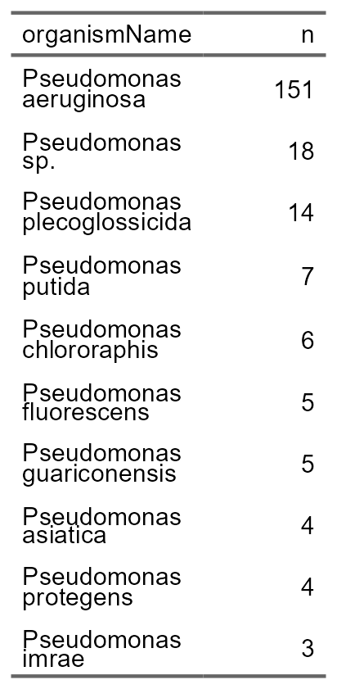

Phylogenetic analysis
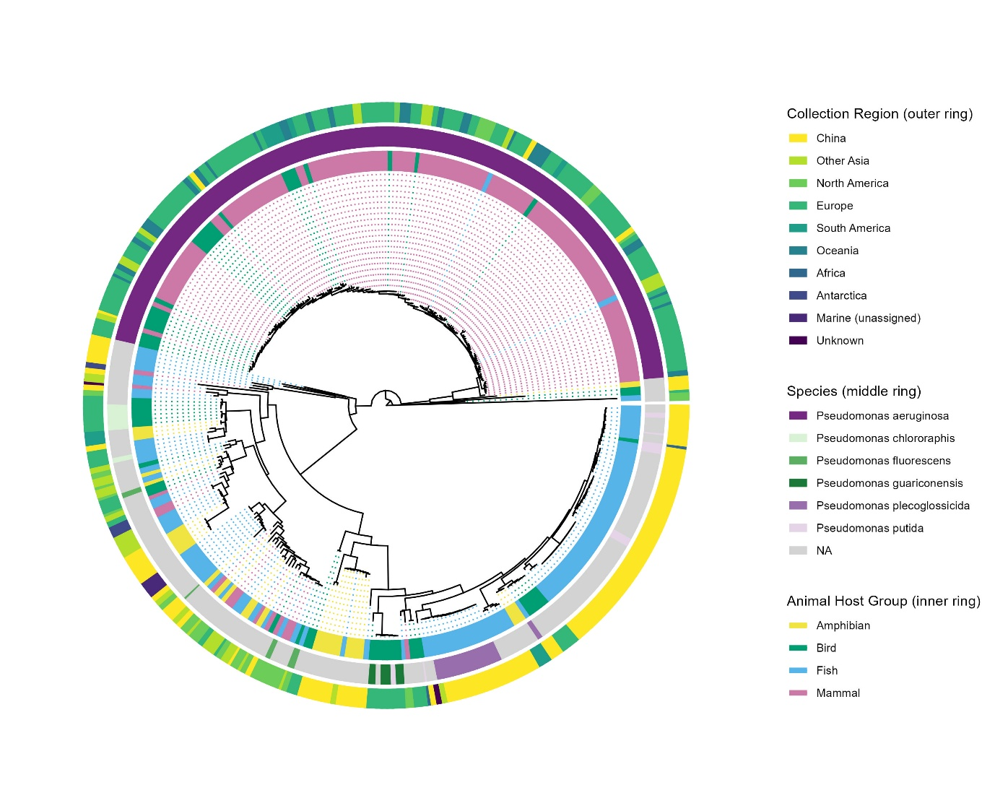
In order to visualize the relationships between the samples of the study. A phylogenetic tree was constructed with GTDB-Tk, visualised in Figure 1. It should be noted, 1 branch had to be cut due to being too evolutionarily distinct from all other samples. Two distinct large groups can be identified on the tree. The taxonomic information added to the tree (middle ring) shows the upper, tightly-knit group corresponds specifically to the species Pseudomonas aeruginosa, and the other more variable group corresponding to the other Pseudomonas species present in the study. This ring also shows that P. aeruginosa is by far the biggest single Pseudomonas species present in the study, with the next largest species only making up a fraction of the study. To search for biases in the data, data on collection region (Outer ring) and host group (inner ring), has been added to the tree. Firstly, large correlation can be seen between P. aeruginosa and mammalian hosts, interspersed with few bird and fish samples, similarly, fish hosts form smaller, but still large clusters of close relation. Bird and amphibian samples are however found throughout the tree. This could imply that there is taxonomic bias in the data, as mammalian-hosted samples largely map to P. aeruginosa, as opposed to having a breadth of variation across the genus. Similarly, figure 1 presents that there is a correlation between fish hosted samples and originating from China. It is highly likely that some sub-clusters of fish-hosted samples originated from a single event where many hosts were sampled, or where a singular host was sampled repeatedly, explaining close correlation. This presents there is likely geographic bias in the data for fish-hosted samples. However, China is a large country, with many climates within its borders and the possibility of samples coming from very distinct environments is higher than some other countries. To group Country-level data into the groups shown in the figure, Claude.ai was again used, decisions shown in Supplementary Table S3.
Figure 1 - Phylogenetic tree showing relationship between wild vertebrate hosted Pseudomonas bacteria (n=336). Added data includes: host Class group (Inner ring), bacterial taxonomic info for the largest species (Middle ring) and region of collection (Outer ring).

Pathway analysis
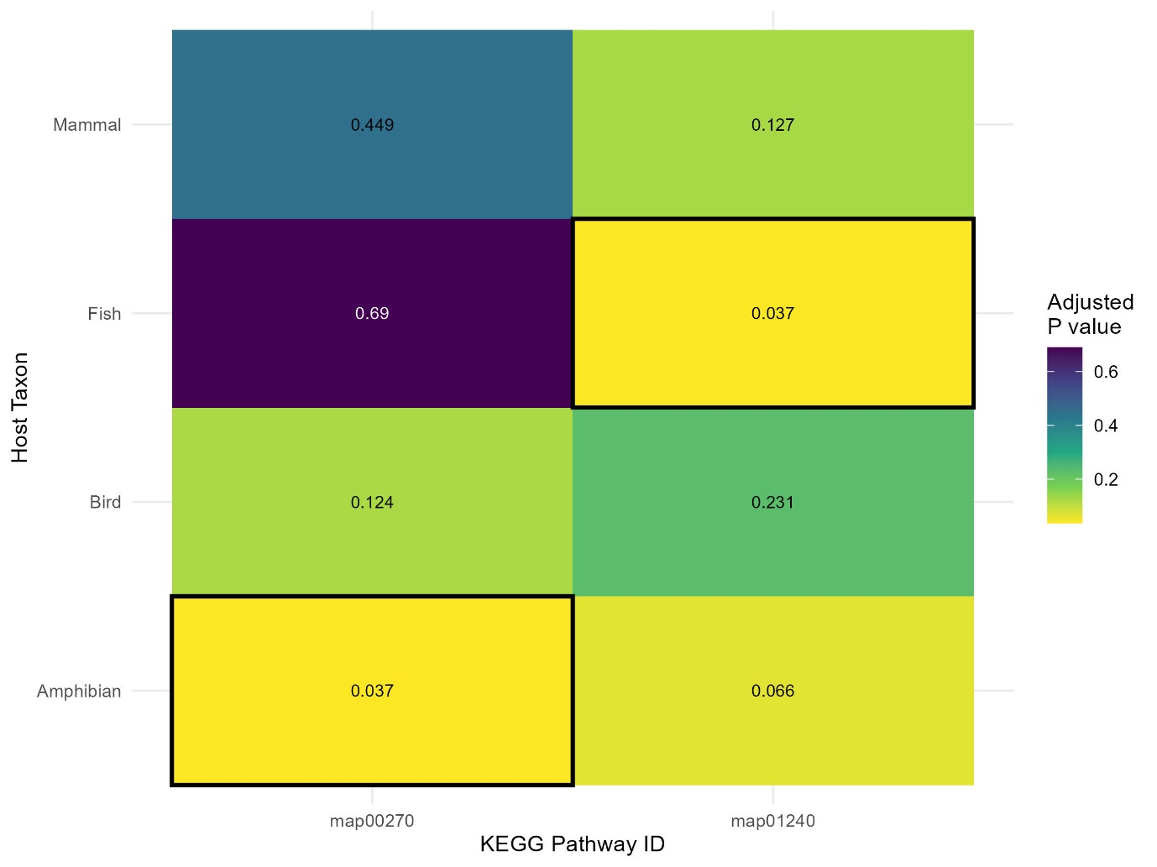
Figure 2 - Heatmap showing significantly enriched pathways between 4 groups of Pseudomonas bacteria, based on host Class. Lighter colour signifies lower P value, in addition, the exact P value is present in each cell. The dark border around some cells indicates a significant correlation between a pathway and a group. An adjusted p value of 0 signifies a value of 0.0009 or lower.
Enrichment analysis, presented in Figure 2, concluded that there were 2 pathways significantly enriched in 1 group (p.adjusted < 0.05) over the other 3 (p.adjusted > 0.05). Specifically, map00270 (Cysteine and methionine metabolism) was found to significantly correlate with Pseudomonas in amphibian microbiomes and map01240 (Biosynthesis of cofactors) was found to significantly correlate with Pseudomonas in the microbiomes of fish.
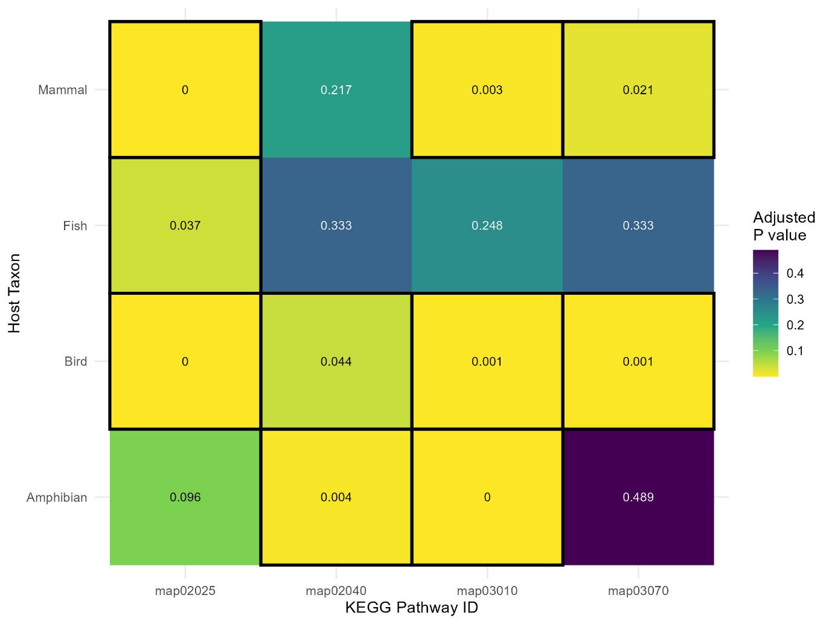
Figure 3 - Heatmap showing shared pathways of significant over-representation between 4 groups of Pseudomonas bacteria, based on host Class. Lighter colour signifies lower P value, in addition, the exact P value is present in each cell. The dark border around some cells indicates a significant correlation between a pathway and a group. An adjusted p value of 0 signifies a value of 0.0009 or lower.

Pathways found to be over-represented in multiple groups, presented in Figure 3, show great variation. Firstly, map 02025 (Biofilm formation - Pseudomonas aeruginosa) is correlated with all groups excluding Amphibian hosts. However, this group barely miss the 0.05 cutoff for inclusion, likely due to the group’s small size of only 30 samples. [this is a conclusion] Map02040 (Flagellar assembly) is found enriched in Amphibian and Bird hosted Pseudomonas. This could be relevant to the isolation source [conclusion] Map03010 (Ribosome) is found in all but Fish-hosted samples. Finally, map03070 (Bacterial secretion system) correlate significantly to Mammal and Bird hosts.

Conclusions
Enrichment
Single-group pathways
Using the adjusted P value, only 6 total pathways were found enriched between the 4 groups. This could speak to the highly conserved core genome of Pseudomonas (ref). Or could be an artifact of data limitations, discussed later, or brought about by an issue with the Benjamini-Hochberg (BH) procedure (ref) [that one paper again]. The pathway map00270 (Cysteine and methionine metabolism) was only found significantly enriched in Amphibian-hosted pseudomonas. Metallothioneins are proteins that have been shown to contain a large proportion of Cysteine, but also have the potential to contain Methionine (Stein et al., 1987). Previous study has focused on Metallothioneins in Amphibians. [build up] (Dobrovoljk et al., 2012). The protein is known to bind heavy metals, it is not believed to have a single primary purpose, but has been shown to provide the individual defence from Cadmium (Cd) toxicity (Coyle et al. 2002). In amphibians, this has been shown to disrupt the concentrations of essential metals, including Selenium, a vital metal found to be used in proteins for the regulation of metamorphosis (Dobrovoljk et al., 2012). This could connote that there is selection for pathways involving the creation of Metallothioneins in amphibians, as well as pathways for the biosynthesis or retention of Cysteine and Methionine. Thus, there would be a selective pressure placed on constituents of the microbiome to metabolise these amino acids, for the biosynthesis of bacterial molecules. However, it is known that metallothionines are present across the vast majority of vertebrate groups, with mammals known to express 4 isoforms (Dobrovoljk et al., 2012). Thus, it is unclear if this is the true cause of the patterns seen in these data. It could be an artifact of small group size (n=30) in amphibians, the parameters of quality were made such to attain this number of samples, meaning that a proportion of this number are of lower-quality (Completeness > 10% and contamination > 5%). However, the Benjamini-Hochberg procedure should account for this. [check numbers, and BH]
The other pathway found solely in 1 group, map01240 (Biosynthesis of cofactors), is associated with Osteichthyes hosts. Though, it should be noted that this pathway was almost significantly correlated with Amphibian hosts as well (p.adjusted = 0.066), so, may be more correlated with an aquatic lifestyle than specifically Osteichthyes hosts. Cheng et al. (2024) also found this pathway enriched in a study centred around the fish species Larimichthys crocea. [build up]

Limitations
Public genomic databases represent a great source of data to supplement genomic analyses. However, this study shows that there are significant limitations to using this source of data. Specifically, in the realms of data quantity and quality. For example, a lot of bacterial samples originate from clinical settings, which is ideal for studying disease, but not useful to understanding wild ecosystem dynamics. For example, the ~60,000 Pseudomonas samples becoming 337 useable samples in the study, a reduction of 99.994%. Similar data quantity limitations exist for other bacterial taxa. Data quality presents similar issues, as can be seen in Supplementary table S2, there is no standardisation in fields such as host, with some researchers using common English names, and some using scientific names. Much of the time, the field is left blank completely, or contains some variation on “missing”. This attributes to the limitations in data quantity, as good genomes are being left on the table due to sub-par metadata. Similarly, there are other fields of interest, in the metadata, such as “Isolation Source”, which suffer similar issues. In the case of this field, some researchers use it as a higher level of granularity, placing the part of the host the sample was taken from, some researchers simply enter the rough location the host was in into the field and again, many leave it blank altogether, making it difficult to discern what the field could be used for. However, it should be noted that the NCBI genomic database represents just 1 of many such sources, it is possible the issues raised are not representative of genomic data repositories everywhere.
Ideally, analysis could be done at species level differences, but there isn’t enough data yet.
There are still issues with standardising the Over Representation Analysis (ORA) pipeline, with a myriad of different tools and methods existing. Many of these are poorly explained, making it hard for new researchers to penetrate the field. (ref) [that one paper, I swear there was one on the limits of ORA]
The data used in the study similarly represents limitations, such as the potential biased caused in the mammalian and fish samples. Similarly, Figure _ shows that each group makes up a significant amount of the background universe, ranging from __ to __, this cold mean there is not enough variation to meaningfully discern over representation, for example, because such a large proportion of the samples are purely the species P. aeruginosa.

Conclusions
Technical aspects
These data have the potential to be flawed, coming from a spurious data source. However, as data is continually added to these databases, the strength of analyses that can be performed through methods such as this shall only increase. Thus, the creation of pipelines such as this, at this point in time, could be valuable to future research, so that the pipelines are prepared when the data is more ideal. In the intervening time, this study suggests that standardisation practices should be implemented across the pipeline, from standardising the use of Latin scientific names for the hosts of bacterial samples uploaded to public genome repositories (Supplementary table _), to the standardisation of methods surrounding Over Representation Analysis (ORA) (ref) [that paper again]. Similarly, as more data is released, significant analysis at the middle (Order and Family) and, later, lower (Genus and Species) taxonomic levels, using only publicly available samples, will become possible. This will be a benefit as the vertebrate classes of this study have much intra-taxa variation, weakening the signals of true adaptation (Table _, the one about the background universe). Opening up a vast wealth of low-cost, novel inferences that can be made to illuminate the ecological relationships of microbes. [Any other suggestions for the field? Something about BH?]
However, this field will benefit from the continual reduction in cost of high-throughput sequencing (NGS) (ref). As well as improvements in sequencing accuracy (ref). As, it is still possible at this time that many researchers do not conduct Metagenome Assembly studies (MAG) on bacteria (ref)[?] of wild animal hosts because of inherent cost, or because it is not seen as scientifically significant, compared with clinical analyses. Similarly, it is possible that many researchers do not expend the effort of uploading their samples onto public repositories. In a similar vein, genomic sequences to only 1 repository, out of a sea of such repositories. Perhaps, for significant analysis, research building on these methods could benefit from taking samples from multiple databases. However, this could come with an issue of duplicating genomes that have been uploaded to more than 1 database. Thus, again, there could be further organising and standardisation public genomic repositories into 1 universal database.
In conclusion, this represents a field of great potential, that requires some major organization and review. [build up or integrate]
Scientific aspects
This study has found signals that, in spite of being generalist bacteria, with large core genomes (ref), there are signals that Pseudomonas bacteria adapt to their hosts, or that perhaps the great variation seen inside this genus of bacteria causes higher fitness in some individuals than others, and these find more success in specific host micro-niches, due to the selection pressures inherently different to different host taxa. This research highlights the need for future research into the over-representation of Cysteine and Methionine in Amphibians.

Data collection and filtering
Many of the Pseudomonas samples on the NCBI genomic database are human clinical samples, these are unideal for this analysis as they represent definite pathogenic events. Similarly, the close contact humans and domesticated animals have with anti-biotics might disrupt signals of true host-association in the microbiome. Thus, only samples from potentially wild hosts were taken.
[suggestions by Wieder et al. (2021) were followed to help standardise the methodology for ORA analysis (?), Zhang et al., 2025 justifies this, I think]
A minimum group size of 30 was chosen, as this is the usual cut off for parametric testing (I think that’s right, but that feels like a weak justification).
Descriptive analysis
In order to describe the data
Data pipeline and processing
Data analysis
[the adjusted p value was calculated with BH (__) which Wieder et al. (2021) say “may not account for correlations between pathways]
Limitations
Working with this data can present challenges, as there is no singular set of defined rules for processing and labelling the samples. [work on] Due to the lack of reliability in the “isolation source” field, it is sometimes difficult to discern where on the individual a sample came from. This can be important as different areas of the body have different bacterial make ups, thus impacting the analysis (ref). Some of the key limitations with ORA are outlined by Wieder et al. (2021). Such as, the use of different pathway databases leading to differing results for pathway enrichment analysis. Similarly, they discuss the important point of the lack of guidelines for a single set method for this analysis.
Data quantity
The vast majority of research is conducted on infectious agents, specifically clinical infections in humans, as this is what is deemed scientifically important. This means there are relatively few samples that are definitely taken from the microbiomes on non-infected wild hosts. Not all taxa are sampled equally. For Pseudomonas being hosted by vertebrate taxa, there are many more mammal and fish hosted samples than bird and amphibian, and there were not even enough reptile samples to pass the threshold of entering the analysis. The genus Pseudomonas was specifically chosen due to the fact it has so many samples in the NCBI genomic database, due to the fact that other bacterial taxa are sometimes found only in small quantities and mostly clinical samples from humans or domestic animals.
(Meta)Data quality
Many samples uploaded to the NCBI genomic database lack sufficient information in the designated field for host to be used in analysis, meaning there are potentially useful samples that cannot be used due to a lack of rigour when the contributors collected or recorded the metadata of the sample. Similarly, there is no naming convention for the host field, meaning one could find latin binomial names, common names for species, or other vague names, including ones with spelling errors. This necessitates the use of artificial intelligence to standardise this field, saving hours of human work it would take to do so.
[pathway analysis is similar to the recent paper released by Zhang et al., 2025.]
In compliance with Wieder et al. (2021) I report:
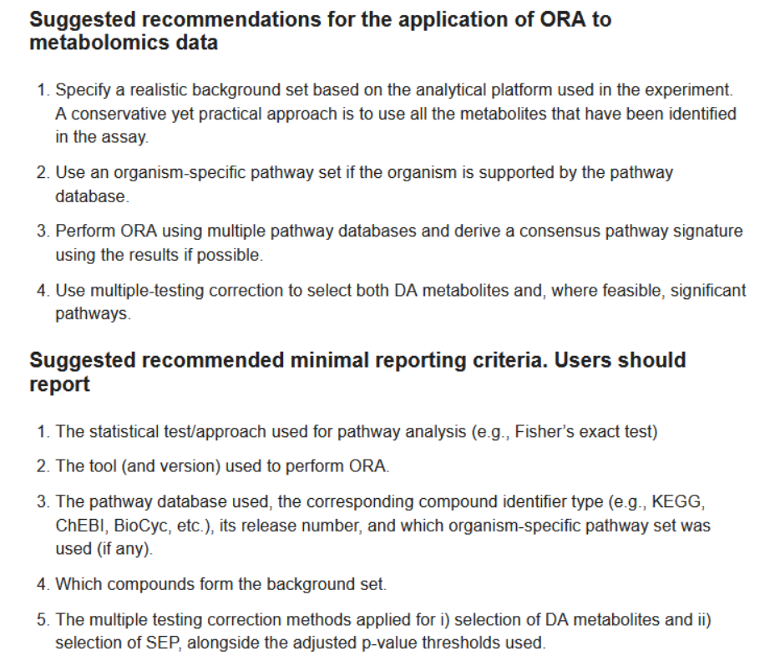
[“The use of p adjusted over q value should not have a significant impact (maybe)]
[“As analysis was not being run inside species, exact methodological following could not be performed”]
KEGG:
Enrichment:
(Ziemann et al., 2024) – justification for custom background and maybe more useful stuff to pull, they give alternative enrichers to cluster/microbiomeprofiler, so maybe need to justify why I used these over those. Maybe “more well-established” or something like that, don’t think “Aaron said to do it that way”, will cut it
Limitations:
Not all the genes are known (Saati-Santamaría et al., 2022) – explains why the lists cut down after enrichKO
The end of santamarias discussion is good for limitations and other stuff

Conclusion:
“It is unsurprising there are this few pathways, as Pseudomonas has been shown to be a generalist with a highly conserved core genome (ref) (ref) (ref)”
But then why are there so few shared pathways? It couldn’t find any significantly enriched for all because it was shared for all, or something like that?, or because of bias, or because of each group making up too much of the background?. Something in there means that even though all groups have the same pathways, they aren’t being seen as enriched for being in any of those groups, depends on what “enriched” means…
Many pathways were not found enriched in any group for some reason, perhaps bias in the data, or the BH adjustment being too aggressive.
“fewer pathways than expected were found with shared enrichment, probably due to funky data, bias, link to tree”
I swear I read a paper that specifically said “Benjamini-Hochberg isn’t perfect”, could play that angle
Enrichment analysis suggest little adaptation

